C:\Users\ajunior.CDNSECOM\Desktop\header_brazil1.jpgPerformance Impact

**IKKI YAMAKAWA, ASAHI SHIMBUN TRIP TO BRAZIL**

**Media Coverage Report**

**Updated 20 October 2011**

**SUMMARY**

|  |  |  |
| --- | --- | --- |
|  | **Analyzed Media** | **Non-Analyzed Media** |
| **Total Placements:**  **5 clips**  (5 original articles) | **5 original articles**  0 reprints | **0 original articles**  0 reprints |

**REGIONAL BREAKDOWN OF ORIGINAL ARTICLES**

|  |  |  |
| --- | --- | --- |
| **Region** | **Analyzed Media** | **Non-Analyzed Media** |
| **Global (Newswires)** | - | - |
| **United States** | - | - |
| **Europe** | - | - |
| **Asia** | 5 | - |
| **South America** | - | - |
| **Other Regions** | - | - |
|  |  |  |
| **Totals** | **5** | **-** |

**HEADLINES**

|  |  |  |  |  |
| --- | --- | --- | --- | --- |
| **NEWS COVERAGE (full text below): 5 total (5 original articles)** | | | | |
| **Region** | **Date** | **Outlet** | **Headline** | **Journalist** |
| A | 13 September 2011 | Asahi Shimbun  (print, evening edition) | **Prospective Country Now: Brazil’s dynamism 1 - Vibrant cities\*** | Ikki Yamakawa |
| A | 14 September 2011 | Asahi Shimbun  (print, evening edition) | **Prospective Country Now: Brazil’s dynamism 2 - Cash for the poor to raise their level\*** | Ikki Yamakawa |
| A | 15 September 2011 | Asahi Shimbun  (print, evening edition) | **Prospective Country Now: Brazil’s dynamism 3 - Foreign investors aiming to the middle class\*** | Ikki Yamakawa |
| A | 16 September 2011 | Asahi Shimbun  (print, evening edition) | **Prospective Country Now: Brazil’s dynamism 4 - Rapid growth contains risks\*** | Ikki Yamakawa |
| A | 25 September 2011 | Asahi Shimbun  (print, morning edition) | **Brazil cautious against the further monetary easing at the developed countries\*** | Ikki Yamakawa |

***\*Note: headlines translated from Japanese to English***

**Key**

= orginal article in analyzed media

***[Outlet]*** =reprint in analyzed media

**Regional Codes:**

* **G** = Global (Newswires)
* **US** = United States
* **EU** = Europe
* **A** = Asia
* **SA** = South America
* **O** = Other Regions

**FULL TEXT**

Asahi Shimbun (print, evening edition)

**Prospective Country Now: Brazil’s dynamism 1 - Vibrant cities (translation)**

By Ikki Yamakawa

13 September 2011

***Lead Sentence Translation:*** Executives are commuting by helicopters, for the roads are full of traffic. Expensive cars sell a lot and personal consumption is extremely strong. On top of that, the natural resource industries are growing fast like Petrobras which has developed Pre-salt. Overall, the Brazilian economy is growing steadily without the influence of turmoil at the western economy.

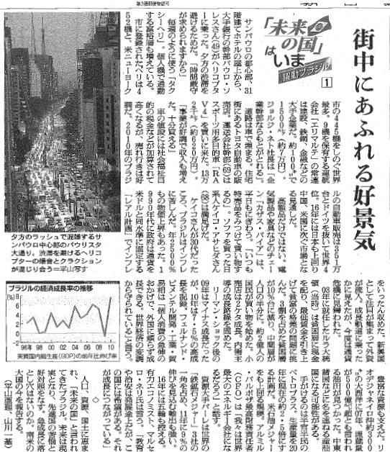

Asahi Shimbun (print, evening edition)

**Prospective Country Now: Brazil’s dynamism 2 - Cash for the poor to raise their level (translation)**

By Ikki Yamakawa

14 September 2011

***Lead Article Translation***: The poor people have obtained the Bolsa Familia program and they are becoming the middle class. They spend a lot for the economy to be boosted. Most of the nation is satisfied with this situation, although some of the existing middle class and the rich complain of heavy tax to support the poor.

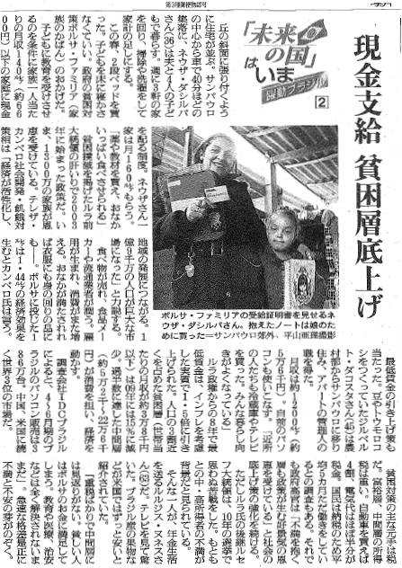

Asahi Shimbun (print, evening edition)

**Prospective Country Now: Brazil’s dynamism 3 - Foreign investors aiming to the middle class (translation)**

By Ikki Yamakawa

15 September 2011

***Lead Sentence Translation:*** Car makers, retailers and food producers have been coming to Brazil for its strong consumption. But Japanese companies are behind the ones from the US, Europe and South Korea.

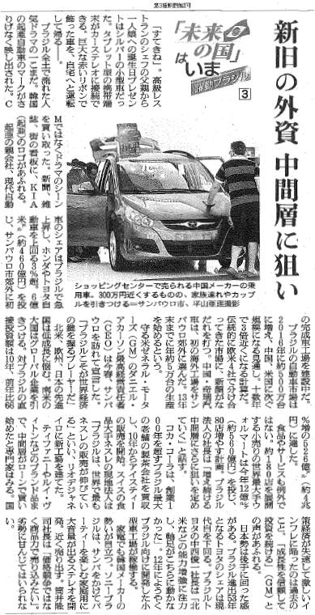

Asahi Shimbun (print, evening edition)

**Prospective Country Now: Brazil’s dynamism 4 - Rapid growth contains risks (translation)**

By Ikki Yamakawa

16 September 2011

***Lead Sentence Translation:*** There’s still concern about the inflation. The real estate price is rising. People spend a lot by using credit cards. The situation is a bit similar to Japan in 1980’s and the US in the 2000’s.

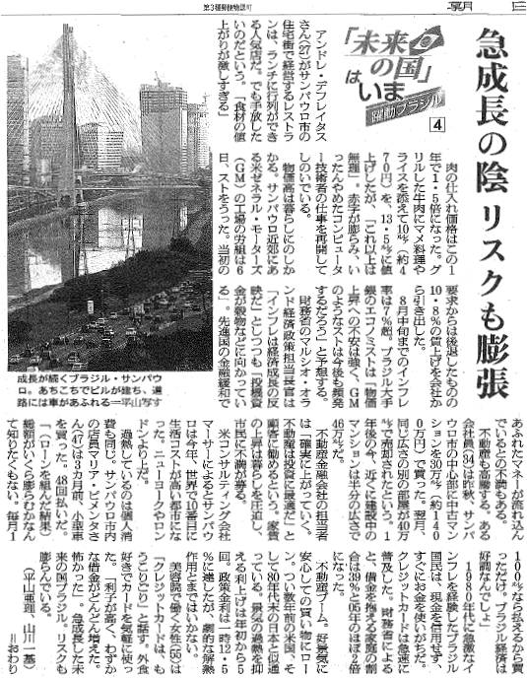

Asahi Shimbun (print, morning edition)

**Brazil cautious against the further monetary easing at the developed countries (translation)**

By Ikki Yamakawa

25 September 2011

***Lead Sentence Translation:*** Exchange rate of Real against the US dollar or Euro has been very much impacted by the US and European monetary policy.

*Note: article cites the following quote from Minister Mantega’s September teleconference:* “Q3 may be the last weapon for the US economy but it causes the problem for the developing countries.”

